SQL Part Summary
Section 1: Who are our customers? (Customer Profile & Demographics)
Q1. Customer composition & Revenue contribution by age group
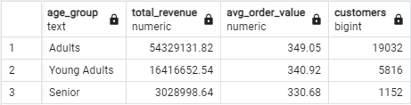
Q2. Revenue split by gender
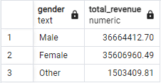
Q3. Top 3 categories by gender
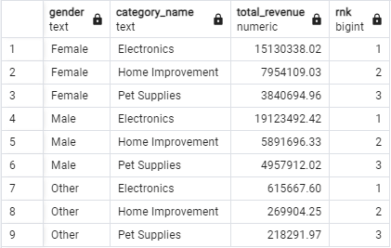

Section 2: How do customers shop? (Purchase Behavior)
Q4. Average purchase value by shipping method
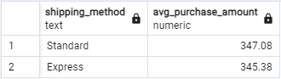
Q5. Discount behavior vs spending power
Which customers placed discounted high-value orders?
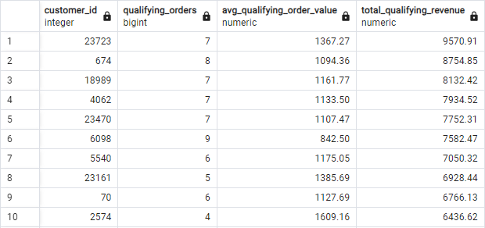
Q6. Discount dependency by product (pricing elasticity)
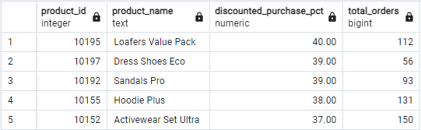
Section 3: What drives sales? (Products & Categories)
Q7. Top-performing products overall (revenue & number of orders)
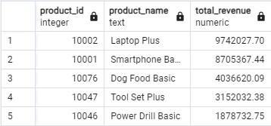
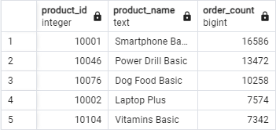
Q8. Top products within each category
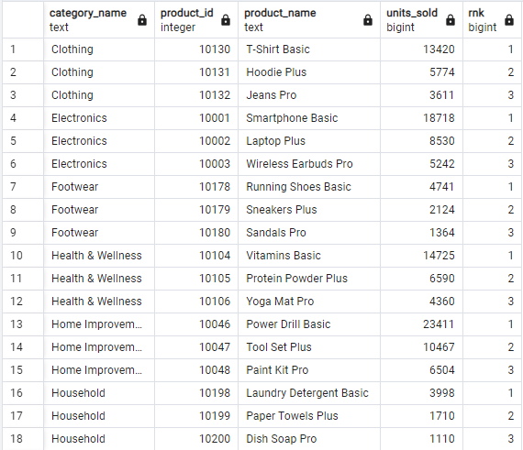
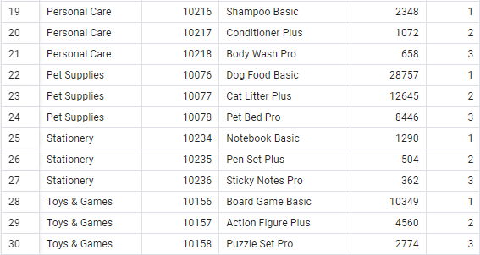
Section 4: Customer loyalty & segmentation (Customer behavior insight)
Q9. Customer segmentation by purchase frequency (New, Returning, Loyal)
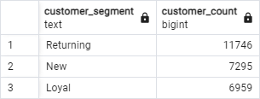
Q10. Do higher-tier members spend more?
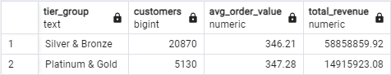
Q11. Are loyal customers less dependent on discounts?
